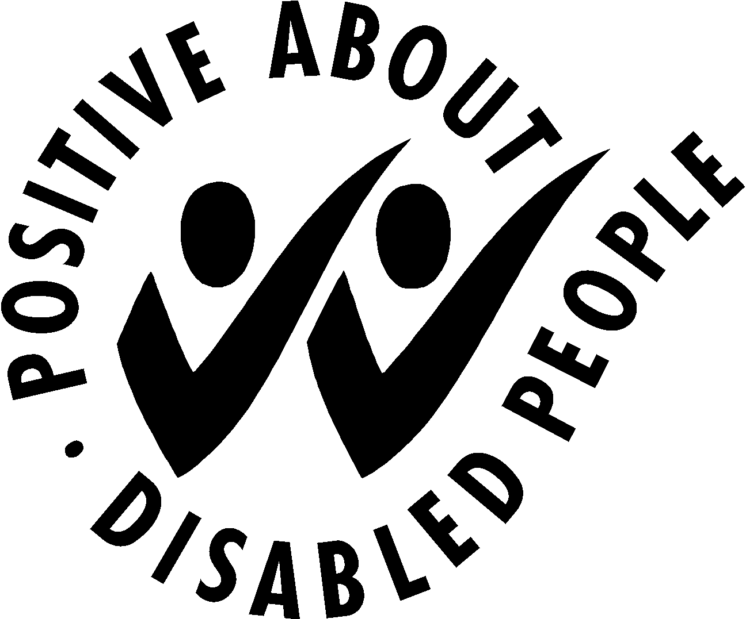

Guaranteed Interview Scheme

If you require this form in an alternative format please let us know

The Department is committed to the employment and career development of disabled people.
We guarantee to interview anyone with a disability whose application meets the minimum criteria for the post. By ‘minimum criteria’ we mean that you must provide us with evidence in your application which demonstrates that you generally meet the level of skills and experience defined as essential within the person specification of this information pack.

The Equality Act 2010 defines someone as a disabled person if a) they have a physical or mental impairment; and b) the impairment has a substantial and long term adverse effect on their ability to carry out one or more normal day to day activities.

Do you wish to claim an interview under the Guaranteed Interview Scheme?

Yes

No

Name:
Date:

If you are applying under this scheme please complete this form and return it with your application form.

